

**Citizenship, Economics and Society**

**(Secondary 1-3)**

**Support Resources**

**Secondary 1**

**Module 1.1**

**Self-understanding and Life Skills**

**Part 4:**

**Media and Information Literacy**

(Self-learning materials included)

Personal, Social and Humanities Education Section

Curriculum Development Institute

Education Bureau

**Introduction**

* The “Citizenship, Economics and Society (Secondary1-3) Support Resources” covers the essential learning contents of Strands 1, 5 and 6 in the Personal, Social and Humanities Education Key Learning Area. It is designed to support the implementation of the Citizenship, Economics and Society curriculum.
* The support resources provide diversified learning activities to help students acquire knowledge and understand concepts, develop skills and nurture positive values and attitudes. In addition, they offer teaching guidelines and suggestions on learning and teaching activities for teachers’ reference. Further, they provide reading materials to enhance students’ interest in reading.
* “Module 1.1 Self-understanding and Life Skills Part 4: Media and Information Literacy” for Secondary 1 was developed by the School of Education and Languages of the Open University of Hong Kong, commissioned by the Personal, Social and Humanities Education Section, Curriculum Development Institute of the Education Bureau.

**Module 1.1 Self-understanding and Life Skills**

**Part 4: Media and Information Literacy**

**Contents**

|  |  |
| --- | --- |
| **Teaching Design** | **Pages** |
| Lesson 1 and Lesson 2: The role of the media in our lives and the potential risks of media information | 4 |
| Lesson 3 and Lesson 4: Media and information literacy | 8 |
|  |  |
| **Learning and Teaching Activities** |  |
| Worksheet 1: The “media” is everywhere | 11 |
| Worksheet 2: Are the potential risks of media information everywhere? | 17 |
| Worksheet 3: Media and information literacy | 31 |
|  |  |
| **Joyful Reading** |  |
| What is the Internet? | 51 |
|  |  |
| **Self-learning Materials** |  |
| Self-learning material 1: The media are closely related to us | 55 |
| Self-learning material 2: Strategy to deal with media information: The four steps of USER | 59 |
|  |  |
| **References** | 62 |

**Teaching Design:**

|  |  |  |  |  |  |  |
| --- | --- | --- | --- | --- | --- | --- |
| **Topic:** | | Media and Information Literacy | | | | |
| **Duration:** | | 4 lessons | | | | |
| **Learning Objectives:** | | * The role of the media in our lives * The benefits and risks brought by the media * The importance of nurturing media and information literacy | | | | |
| **Lesson 1 and Lesson 2 (The role of the media in our lives and the potential risks of media information)** | | | | | | |
| **Pre-lesson Preparation:** | | Students shall finish the following activities before the class:  - “The ‘media’ is everywhere” in Worksheet 1;  - “Activity 1: I ‘see’ media information” in Worksheet 2. | | | | |
|  | |  | | **Suggested lesson time** | | |
| **Enquiry Process:** | | 1. **Set:** The teacher invites students to share their opinions and check their answers for “Activity 1: What is the media” in Worksheet 1 and then summarises what the media are and brings out the rise of new media*.   *\*The teacher can use Appendix 1 “Know more: “New, new, new” new media” to help students understand the development and evolution of new media.*  *\*Notes for teachers on catering for learner diversity: The teacher can ask students with higher ability levels to finish “Activity 2: The media are always around me” in Worksheet 1, while less able students can answer the second part of this activity directly.* | | 5 minutes | | |
| 1. **Interactive teaching:**  * **Class discussion:** The teacher invites students to share their answers for “Activity 2: The media are always around me” in Worksheet 1. * **Summary:** The teacher summarises the class discussion and asks students the following question: * Can we live without the media? Why? | | 20 minutes | |
| 1. **Interactive teaching:**  * **Direct instruction:** The teacher briefly introduces Worksheet 2 “Are the potential risks of media information everywhere?” and guides students to understand that the media are closely related to our lives and we need to receive information with a proper attitude so that we can avoid falling prey to false information. * **Class discussion:** The teacher invites students to share their answers for “Activity 1: I ‘see’ media information” in Worksheet 2. The teacher can ask students to show their answers by using the application “Socrative or by asking students to vote by a show of hands. * **Summary:** The teacher summarises the class discussion and asks students the following question: * Have you ever believed in false information?   *\*Notes for teachers on catering for learner diversity: Students with higher ability can further understand the concepts of “fake news” and “content farm”.*   * **Extended learning:** The teacher encourages students to study Self-learning material 1 “The media are closely related to us”. | | 15 minutes | |
|  | 1. **Interactive teaching:**  * **Direct instruction:** The teacher briefly introduces “Activity 2: Do you believe?” in Worksheet 2. * **Group discussion:** Students work in groups of 4 to discuss the cases in “Activity 2: Do you believe”. The teacher invites several groups to share their answers. * **Student reflection:** The teacher guides students to reflect on methods to confirm the authenticity of news and remind students to think carefully the contents of news and their impacts before they “like” or “share” them.   *\*The teacher can ask students to find out the truth behind fake news after the class and how people concerned should cope with it, with a view to deepening students’ understanding of this part of the lesson.* | | 10 minutes | |
| 1. **Interactive teaching:**  * **Direct instruction:** The teacher briefly introduces “Activity 3: Who are the victims? Who are the ‘assailants’?” in Worksheet 2 and guides students to understand the impacts brought by fake news. * **Group discussion:** Students work in groups of 4 and discuss the cases in “Activity 3: Who are the victims? Who are the ‘assailants’?” in Worksheet 2. * **Group presentation and class discussion:** The teacher invites each group to present their discussion results. Students listen to the discussion results of different groups and reflect on the questions raised by the teacher and peers, which will help deepen students’ understanding of the impacts of fake news on the public and nurture students’ rational thinking and analysis skills. * **Summary:** The teacher guides students to understand that there are many traps in media information, and we need to be careful all the time and use media with a proper attitude so as to avoid causing problems for ourselves and others. | | 15 minutes | |
| 1. **Student reflection:** Students work in pairs to discuss and complete the reflective questions of “Activity 3: Who are the victims? Who are the ‘assailants’?” in Worksheet 2 according to what they have learned in the class and their personal experience. | | 5 minutes | |
| 1. **Teacher debriefing:**  * The teacher summarises the discussion results and make a conclusion by using Appendix 3 “Know more: Cracking down fake news” and Appendix 4 “Know more: Laws of Hong Kong related to media use: Some examples” so as to help students to integrate the influence of the media on our lives and the risks brought by it. * The teacher encourages students to be more aware of their daily habits and reflect on the following questions: * What role do the media play in our lives? * What impacts do the media have on individuals? * The teacher reminds students to enhance awareness and vigilance, nurture media literacy, learn to think critically and identify the authenticity and integrity of the sources of information. | | 10 minutes | |
| **Extended Learning Activity:** | Students read Appendix 1: “Know more: “New, new, new” new media”; Appendix 2: “Know more: Careless media and careless information receivers!”; Appendix 3: “Know more: Cracking down fake news”; and Appendix 4: “Know more: Laws of Hong Kong related to media use: Some examples” after class and reflect on their contents. | |  | |
| **Learning and Teaching Resources:** | Worksheets 1-2; Appendixes 1-4; Self-learning material 1 | | | |

|  |  |  |
| --- | --- | --- |
| **Lesson 3 and Lesson 4 (Media and information literacy)** | | |
| **Pre-lesson Preparation:** | Students complete the activities in Worksheet 3 “Media and information literacy” before the class. | |
|  | | **Suggested lesson time** |
| **Enquiry Process:** | 1. **Revision:** The teacher reviews the key learning points of Lesson 2 with students. | 5 minutes |
| 1. **Set:**  * **Direct instruction:** The teacher briefly introduces “Activity 1: What is media and information literacy” in Worksheet 3. * **Video watching and class discussion:** The teacher plays the “‘3-minute Concept’ Animated Video Clip Series: Media and information literacy” and guides students to carry out class discussion so that they can understand and review the importance of media information literacy and learn about how to improve personal and social media literacy. * **Student reflection:** The teacher guides students to analyse the impacts of receiving and sharing false information on individuals and the public, based on the definition of media and information literacy and the coping strategies mentioned in the previous lessons, as well as students’ personal sharing, so as to bring out the consequences of lacking media and information literacy. | 10 minutes |
| 1. **Interactive teaching:**  * **Direct instruction:** The teacher briefly introduces “Activity 2: Nurturing media and information literacy” in Worksheet 3; and then explains the points-to-note while analysing media information and the common network effects. * **Group discussion:** Students shall work in groups of 4 and analyse and discuss the case study in “Activity 3: Nurturing media and information literacy: Case study” in Worksheet 3. * **Presentation and class discussion:** The teacher invites each group to present their discussion results. * **Teacher debriefing:** The teacher summarises the class discussion to help students understand the importance of nurturing media and information literacy and the negative effects brought by “false information”. | 30 minutes |
| 1. **Interactive teaching:**  * **Direct instruction:** The teacher briefly introduces “Activity 4: Strategy to deal with media information: Stop, Read, Listen and Care” in Worksheet 3. * **Pair work:** Students work in pairs to analyse the materials in “Activity 2: Nurturing media and information literacy” using the Stop, Read, Listen and Care strategies. The teacher then invites groups to share their discussion results. * **Extended learning:** The teacher encourages students to study Self-learning material 2 “Strategy to deal with media information: The four steps of USER”. | 25 minutes |
| 1. **Conclusion:**  * The teacher concludes the importance of nurturing media and information literacy. * The teacher encourages students to be the masters of the media and remind them to deal with information carefully so as to avoid falling into the traps of fake information and causing great loss or bearing civil/criminal liability. | 10 minutes |
| **Extended Learning Activity:** | Students read Appendix 5: “Know more: Identifying false reports” and “Joyful reading: What is the Internet?” and then reflect on relevant questions. | |
| **Learning and Teaching Resources:** | Worksheet 3; Appendix 5; Self-learning material 2 | |

**Module 1.1 Self-understanding and Life Skills**

**Part 4: Media and Information Literacy**

**(Lessons 1 and 2)**

**Learning and Teaching Materials**

**Preface**

With the development of information technology, Internet media are booming. Modern media have been shifting to two-way communication. That is to say, the two parties, disseminators (information disseminators) and receivers (information receivers), communicate with each other and share information. Meanwhile, people receive and share information without being limited by time and space, which greatly increases the amount and flow of information. As a result, the media have become an indispensable part in our lives. However, do you know what the media is? In this module, we will learn about how the media are closely related to our lives, discuss the functions of the media and the benefits and risks brought by it, with a view to bringing out the importance of nurturing media and information literacy.

**Worksheet 1: The “media” is everywhere**

The teacher asks students to finish Worksheets 1-2 before the class and then carries out a discussion and sharing activity during the class.

The media refer to dissemination tools, which is also known as mass media. How much do you know about the media?

**Activity 1: What is the media?**

**Quiz**

**Know more**

The term媒介(Medium) was first published in the *Cheung Hang-sing Biography The Old Book of*Tang*History*: “Throughout ancient and modern times, every employment occurred because of media”. Media refer to the people or things that work as intermediaries in forming relationships between two or among more parties. The character “媒” referred to matchmakers in the Pre-Qin Period and gained its extended meaning of the causes of things later.

Excerpted and adapted from: 郝雨 (2015), 《中國媒介批評學（上）》.

The teacher provides words in the dotted box to help less able students to complete this activity.

Magazines, Radio stations, Digital broadcasts, Journals, Comics, Mobile communication apps, Blogs, Movies, Car wrap advertisements, E-books , MP3, Short messages, Instant messaging tools, Instagram, Books, Facebook, Online forums, Neon signs

Try to give at least two examples for each of the following media.

|  |  |
| --- | --- |
| **Traditional media** | Example: Newspapers  *Suggested answer: magazines, journals, books and comics.* |
| **Electronic media** | Example: Televisions  *Suggested answer: Movies and radio stations* |
| **Digital media** | Example: Digital Televisions  *Suggested answer: E-books, digital broadcasts and MP3* |
| **Social media** | Example: Mobile communication apps  *Suggested answer: Short messages, instant messaging tools, Instagram, Facebook, blog and online forums* |
| **Outdoor media** | Example: Advertising space on guide boards and light boxes  *Suggested answer: Neon signs and car wrap advertisements* |



Appendix 1

**Know more: “New, new, new” new media**

**The development of the media**

|  |  |
| --- | --- |
| **Old media** | The media before the appearance of the Internet, such as books, newspapers, magazines, journals, televisions, radio broadcasts, etc. |
| **New media** | The media which emerged in the Internet age in the mid-1990s, such as online forums, online newspapers, e-mail, etc. |
| **New, new media** | Social media, such as mobile phones, blogs, Facebook, Instagram, YouTube, etc. |

In 2009, someone proposed to explain the existing new media with the concept of “New, new media”. It turns out that some scholars have put forward the term “new media” as early as 1953 to describe the new communication platform of that time. However, the mode of media communication has been changing rapidly. New media of today will become old media tomorrow.



NEWS

NEWS

Excerpted and adapted from: Levenson (2009), New new media.

The teacher encourages students to study Self-learning material 1 “The media are closely related to us”.

The teacher asks students with higher ability to finish this part, while less able students can answer the second part of this activity directly.

**Activity 2: The media are always around me**

1. Answer the following questions according to Activity 1.

Think about the media you had come into contact with yesterday and the activities you had conducted using these media, and fill in the table below.

**My day with the media**

|  |  |  |  |  |  |
| --- | --- | --- | --- | --- | --- |
|  | **What are these media?**  **(WHAT)** | **What are the types of these media?**  **(WHAT)** | **When did I come into contact with these media?**  **(WHEN)** | **Where did I come into contact with these media? (WHERE)** | **Which activities I had conducted using these media*?**  **(WHICH)** |
| Example 1 | Television | Traditional media | During breakfast | Home | Receiving news and weather information |
| Example 2 | Facebook | Social media | On my way home from school | MTR | Interacting with net friends |
|  |  |  |  |  |  |
|  |  |  |  |  |  |
|  |  |  |  |  |  |
|  |  |  |  |  |  |
|  |  |  |  |  |  |
|  |  |  |  |  |  |
|  |  |  |  |  |  |
|  |  |  |  |  |  |

(*For example: social interaction; entertainment; receiving daily life information, interesting news, current events, government news; online learning; online shopping; etc.)

1. Fill in the blanks below with appropriate answers to see if the media are always around you!

According to the above form:

* I came into contact with (number) media yesterday!
* I received (number) messages from the media yesterday.
* The type of media that I come into contact with most frequently is　　　　　　　　　.
* The media that I mainly use are*:　　　　　　　　　　　　　　　　　(You can write down one or more media). (*For example: WhatsApp, Facebook, Instagram, etc.)
* My most frequently used media functions ** are

　　　　　　　　　　　　　　　　　　　(You can write down one or more functions).

(**For example: social interaction; entertainment; receiving daily life information, interesting news, current events, government news; online learning; online shopping etc.)

When you use the media for activities such as receiving information or socializing, do these activities involve countries or regions outside Hong Kong? If so, try to give two examples of activities that involve countries or regions outside Hong Kong.

________________________  
________________________　  
________________________　  
________________________

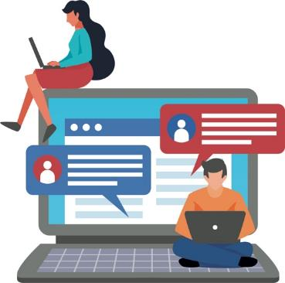

(Your name)

Reflective questions:

1. Can we live in a world without the media? Why?

|  |
| --- |
| *Suggested answer:*   * *No, we can’t. Because the media has become an indispensable part of our lives. Using the media to receive all kinds of important information, especially news or government information, has brought a lot of convenience to our lives. Without the media, we would feel out of touch with society.* |

1. What benefits do the media bring to our lives? Try to give one example. On the other hand, what harm do the media bring to us? Try to give one example.

|  |
| --- |
| *Suggested answer:*   * *The media have brought many benefits to our lives. For example, TV programs can make me feel relaxed; newspapers provide diversified information; the Internet provides quick access to information, making it more convenient to collect information. Besides, with the media, we can get weather information as early as possible and make appropriate preparation and responses; we can know about the big events of our society, the government, the country and the world; we can contact our family and friends regardless of time and place; the media provide different learning opportunities and contents.* * *The media may also bring negative impacts to our lives. In particular, the media may influence our thoughts and behaviours. For example, it might advocate consumption, which may cause us to make unnecessary purchases. People who are addicted to the Internet will ignore real interpersonal relationships* |

1. Based on your experience of using the media, have you ever faced a crisis or unpleasant experience? If so, please share it with the classmate sitting next to you. If not, please find a classmate with relevant experience and listen to his/her sharing.

|  |
| --- |
| *Suggested answer:*   * *Unpleasant experience: I often feel troubled because of receiving some junk and advertising messages.* * *Crisis: Once I found myself addicted to the media. I neglected my family and friends and did not get enough sleep at night. As a result, I was unable to concentrate during classes. I had tried to get rid of this bad habit, but when I couldn’t use the media, I felt lost.* |

**Conclusion**

In the information age, the Internet has been widely used and gained popularity, followed by constant changes in the forms of the media. Media are closely related to our lives. The Internet based media have gone beyond the limitations of time and distance, changed our ways of living and brought conveniences to our daily lives. For example, we can have our daily needs met without the need to leave home, such as shopping, paying bills, receiving information on current affairs and daily life information, education, entertainment, social interaction, etc.

However, due to the diversified functions of the media, we come into contact with plenty of information of all kinds every day. If we don’t enhance our awareness, we will be easily affected by information in many ways, such as judgments of things, values, emotions and behaviours, etc. Therefore, although different forms of media provide people with a range of benefits, there are potential risks. Hence, we should not take the impact of media lightly, otherwise the consequences will be incalculable.

**Worksheet 2: Are the potential risks of media information everywhere?**

In the age of information explosion, the media have brought various benefits to our lives and played diversified functions and an indispensable role. At the same time, we should be more alert to the potential risks of media information so as to avoid falling into traps of false information which may cause economic loss, endanger personal safety or get ourselves involved in illegal acts.

**Activity 1: I “see” media information **

In Worksheet 1, we have discussed that we receive a lot of information from different media every day, but the quality of the information varies. If we do not carefully read and analyse the information we receive, there will be risks.

What is your main attitude towards receiving media information? Complete the following questions to find out the risks which will arise from different attitudes towards receiving media information.

1. What is your main attitude towards receiving media information?
2. Accept all the information [Totally believe the information]
3. Verify [Check the information to see if it is true]
4. Watch it and do nothing about it afterwards [Do not treat it seriously or do not believe it]
5. Forward it after watching [Share with friends]
6. Why do you take such an attitude?

*(Students shall answer freely)*

**Risk analysis**

**A. Fail to distinguish the authenticity of information**

**B. Have the chance to distinguish true and false information**

**C. Don’t know the authenticity of information**

**D. Have the chance to believe false information and even become an accomplice of rumor makers**



Appendix 2

**Know more: Careless media and careless information receivers!**

In this era when people are pursuing “fast”, “interesting” and “new” in everything, some media and netizens will forward media information without first verifying its authenticity, or even create fake news or emotional and negative remarks in order to attract others’ attention.





**Content Farm (內容農場)**

Content farm refers to the phenomenon that some websites or enterprises create a large number of low-quality online articles for obtaining high click rates and profits from online advertising. Most of these articles are copied and pasted from other websites, which lack information sources and even spread misleading information.

**Fake News**

Fake news refers to the purposeful dissemination of unfounded information, including wrong and misleading information, biased remarks, pranks and even malicious attacks, through mimic traditional news media or social media, in order to obtain benefits or express their emotions.

More importantly, fake news will use exaggerated news headlines to ensure high click rates, which are also known as **Clickbaits (釣魚式標題)**.

Excerpted and adapted from: Lazer, et al. (2018), The science of fake news; Merskin (2019), The Sage international encyclopedia of mass media and society.

**Activity 2: Do you believe?**

Please put a tick “✓” to show whether you believe it or not and indicate your reasons.

|  |  |
| --- | --- |
|   **People took pictures of a typhoon eye from a plane** | |
| **Believe 🗹 Don’t believe 🞎**  **Reason:** *This is a real picture and the Observatory has confirmed its authenticity.* | |
| **The monthly income of a CSSA household is HK$22,000** | | **Hanging a sheep’s head and selling dog meat? Dogs are barking in the restaurant** | |
| **Believe 🞎 Don’t believe 🗹**  **Reason:** *The Social Welfare Department has clarified that it is only HK$14,000.* | | **Believe 🞎 Don’t believe 🗹**  **Reason:** *I will decide whether to believe it or not after the relevant evidence is verified.* | |

Source: Hong Kong Observatory (24 September 2019), True. Uncle took pictures of a typhoon eye from a plane; Ming Pao (27 October 2017), A restaurant in Yuen Long is accused of selling dog meat--Owner’s wife feels wronged: we clarified that it was mutton at the beginning of the year; Sing Tao Daily (7 October 2016), It is said online that the monthly income of a CSSA household of 4 is HK$22,000. The Social Welfare Department clarified: it is only HK$14,000.

Reflective questions:

1. Based on the answers to the above activities, what attitudes or actions do you think we should adopt before deciding whether or not to believe some media information?

|  |
| --- |
| *For example:*   * *We should not accept media information without studying it more closely. Instead, we should check relevant information on credible websites or check with relevant professionals first.* |

1. Did you ever believe false media information? What did you do afterwards? Why did you do it? Try to give one example.

|  |
| --- |
| *For example:*   * *I received messages from different friends that a free social media would start charging on the following day and those who forwarded the messages could be exempted. Therefore, I forwarded a lot of messages. The social media clarify that the news about fee charging is fake news.* * *Reason: I believed the rumor without verification.* |

1. Did you ever fail to believe real media information? Why didn’t you believe it? Try to give one example.

|  |
| --- |
| *For example:*   * *I saw a man throwing cash from a rooftop on social media. I think it was just a scene in a movie. Later, I read the news and knew that it was a real event.* * *Reason: I judged the authenticity of events with my gut feeling and have not tried to verify the information.* |

**Activity 3: Who are the victims? Who are the “assailants”?**

It is difficult to distinguish between fake and real media information. Many people disseminate unverified information without considering the consequences of doing so. Some people take such information as true and make negative remarks on others without verification, with the result that innocent people are hurt. Besides, in the world of the Internet, all people can participate in open discussion forum, where there will be a rich interflow of information. However, people will easily loosen up their self-restraint in expression, which will easily lead to cyber-bullying. Besides, as it is difficult to distinguish between what is true and what is false about people and events, many criminals take advantage of it to gain profits or commit illegal acts. Here are some cases. Students shall work in groups of 4, with each group reading one of the cases and complete the discussion questions.

**Case 1: The owner of a restaurant felt deeply disturbed by a wrong accusation that his restaurant was selling dog meat.**

Someone uploaded a post to a social media group concerned with protecting animal rights that a mutton stew restaurant was suspected of “hanging a sheep’s head and selling dog meat”. The person uploaded two photos and accused the restaurant of killing dogs and selling dog meat. One picture showed a cooked animal body with limbs and head removed. The post and the photos attracted lots of attention and were forwarded many times. Some netizens thought that “it is truth as it is clearly shown in pictures”. Besides, some netizens claimed that some residents living close to the restaurant heard dogs’ crying sounds every day. Even though the restaurant owner had made clarifications many times, he was still being bullied on the Internet by netizens. He was even harassed and scolded by them in real life. This false accusation led to a sharp decline in his business and he also suffered from emotional distress. Later, the Food and Environmental Hygiene Department issued a laboratory report verifying that the samples of this restaurant were mutton and the bullying and attacks finally stopped. When the restaurant owner was interviewed by the media, he burst into tears and said justice was finally served!

Source: Oriental Daily (28 October 2017), Owner of the restaurant which is accused of selling dog meat said it was mutton; Ming Pao (27 October 2017), A restaurant in Yuen Long is accused of selling dog meat--Owner’s wife feels wronged: we clarified that it was mutton at the beginning of the year.

Case 1 Questions for discussion:

1. What were the impacts of false information and untrue reports on the innocent restaurant owner?

|  |
| --- |
| *Suggested answer:*  *The restaurant owner was bullied by netizens ganged up against him. Besides, they also harassed and scolded him in real life. His business suffered a sharp decline, and the reputation of his restaurant and his emotion were badly affected.* |

1. To some netizens, this event reflected that people’s lack of rational thinking and analysis of media information would lead to irrational behaviours and a lack of proper values/attitudes. Try to complete the following table regarding this case.

|  |  |  |  |
| --- | --- | --- | --- |
|  | **Give two examples which show a lack of rational thinking and analysis** | **Give two examples which show irrational behaviours** | **Put a tick “✓” in the box to indicate the proper values/attitudes** |
|  | *Suggested answer:*  *（Netizens who uploaded or disseminated the post）*   * *They uploaded unverified and untrue information.* * *They shared and forwarded the post without thinking about the consequences.* * *They uploaded and shared the information of the restaurant ignoring the consequences.* | *Suggested answer:*   * *They bullied the restaurant owner online.* * *They harassed and scolded the owner in real life.* * *They forwarded media information online without verification.* | * Responsibility * Empathy * Rationality * Discernment * Carefulness in words and deeds * Others, please specify: ________________ |
|  | *（Information receivers）*   * *They believed unverified or untrue information easily.* * *They blindly believed that “photos” were evidence.* |  | * Responsibility * Empathy * Rationality * Discernment * Carefulness in words and deeds * Others, please specify: ________________ |

1. Based on what you have learned from this event, what do you think we should pay attention to while dealing with media information?

|  |
| --- |
| *Suggested answer:*   * *We should spend some time to think about the authenticity of information, the motives behind it and the impact of forwarding it on others.* * *We should look at some more other information for reference to see if there are misleading and biased elements in it.* * *Before deciding how we should deal with media information, we should consider others’ feelings.* |

**Case 2: An unemployed post-80s man used dating apps to trick others for money and sex.**

A 32-year-old unemployed man used dating apps to get to know the victims and cheated 12 victims, including 11 women and 1 man, out of HK$ 1,500,000 in total. The suspect lied to the victims that he was a businessman who came from a reputable family, had a high paying job and was rich. He would claim that he had lost his wallet, ID card and other important documents and ask the victims to lend him money. And then, he would further deceive them, including borrowing and extorting money repeatedly. The most serious case was that a victim was forced to take intimate photos during their meeting, extorted and even taken to a hotel and raped.

Source: LEI Pui-man (2018), Being insatiable + Retreating for advance They are skilful in online love scams.

Case 2 Questions for discussion:

1. What were the impacts of this Internet fraud on the victims?

|  |
| --- |
| *Suggested answer:*   * *The victims were cheated out of money and sex. As a result, they got hurt physically and mentally.* |

1. To some netizens, this event reflected that people’s lack of rational thinking and analysis of media information would lead to irrational behaviours and a lack of proper values/attitudes. Try to complete the following table regarding this case.

|  |  |  |  |
| --- | --- | --- | --- |
|  | **Give two examples which show a lack of rational thinking and analysis** | **Give two examples which show irrational behaviours** | **Put a tick “✓”in the box to indicate the proper values/attitudes** |
|  | *Suggested answer:*   * *They easily believed the information provided by the stranger online without analysing the authenticity of the information in detail.* | *Suggested answer:*   * *They easily lent money to the stranger.* * *They accepted the dating requests of the stranger easily.* | * Self-protection * Discernment * Prudence * Others, please specify: ________________ |
|  | * *They blindly accepted the excuses and inappropriate requests of the fraudster for many times, failed to raise awareness of possible scams, and failed to analyse the motives of the fraudster.* | * *They easily accepted the invitation to go to somewhere private and take intimate photos.* | * Self-protection * Discernment * Prudence * Others, please specify: ________________ |

1. Based on what you have learned from this event, what do you think we should pay attention to while dealing with media information?

|  |
| --- |
| *Suggested answer:*   * *We must be careful when making friends with strangers on the Internet, and we should not go out with them alone; we should not easily accept the requests of strangers, such as borrowing money, dating and taking intimate photos; we should discuss with our family, teachers and friends.* |

**Case 3: The personal data of a victim of a rape and robbery case was disclosed.**

Some netizens commented on the event of a girl being raped and robbed on her way home. Some unscrupulous netizens conducted a “human flesh search” on the victim. The identity of the girl was made public and widely forwarded and discussed, and some even made jokes about her experience. Some netizens thought that we should treat the victim with empathy and the disclosure of her identity would cause harm to the victim and her family for a second time. There were also netizens who accused those who disclosed her personal data of breaking the law. Regardless of the authenticity of the data, they had bad motives and what they had done against the victim was like rubbing salt on the victim’s wound. And there was a big chance that they had committed criminal offences under Section 64 of the Privacy Ordinance and other criminal offences. For example, in response to the loss of the victim, the police could prosecute netizens concerned for the offence of “accessing to computer with criminal or dishonest intent”. Besides, the affected person could also claim civil compensation from the person concerned for the injury caused by the “disclosure of her personal data”.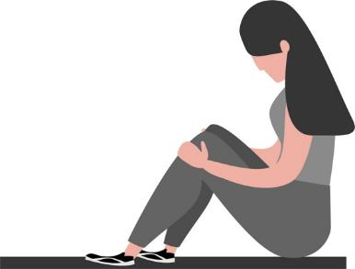

Source: Oriental Daily (11 May 2017), After 70 hours’ hunting, the criminal of the rape and robbery case was arrested in Kowloon Bay.

Case 3 Questions for discussion:

1. What were the impacts of “personal data disclosure” on the victim?

|  |
| --- |
| *Suggested answer:*  *The privacy of the victim was infringed by the behaviour of “disclosing her personal data”; the victim and her family got hurt for a second time; the victim felt deeply distressed which would seriously affect her daily life; the victim had difficulties stopping the continuation of the disclosure of her personal data.* |

1. To some netizens, this event reflected that people’s lack of rational thinking and analysis of media information would lead to irrational behaviours and a lack of proper values/attitudes. Try to complete the following table regarding this case.

|  |  |  |  |
| --- | --- | --- | --- |
|  | **Give two examples which show a lack of rational thinking and analysis** | **Give two examples which show irrational behaviours** | **Put a tick “✓”in the box to indicate the proper values/attitudes** |
|  | *Suggested answer:*   * *They failed to think about the consequences of their responses and sharing of the information, which would be causing trouble and harm to the victim.* * *They didn’t think about that they might be liable for disclosing the information of the victim.* | *Suggested answer:*   * *They publicised and disseminated the personal data and information of the victim.* * *They talked about the event on the Internet, causing endless topics about it.* * *They joked about the suffering of the victim.* | * Respect for others * Ethics * Kindness * Empathy * Carefulness in words and deeds * Observance of the law * Self-discipline * Others, please specify: ________________ |
|  |  |  | * Respect for others * Ethics * Kindness * Empathy * Carefulness in words and deeds * Observance of the law * Self-discipline * Others, please specify: ________________ |

1. Based on what you have learned from this event, what do you think we should pay attention to while dealing with media information?

|  |
| --- |
| *Suggested answer:*   * *We should not bully others on the Internet, such as cursing, abusing and spreading personal information of others, out of curiosity or vanity without considering the feelings of victims. Meanwhile, we should notice that some behaviours may infringe others’ privacy, advocate the culture of “disclosing others’ personal data” and break the law. Therefore, while dealing with information, we should think twice and consider whether we are incited, used or misled.* |

Reflective questions:

1. Sum up the above cases and try to list three media information behaviours that have led to the occurrence of the cases.

|  |
| --- |
| *Suggested answer:*   * *The victims easily believed the lies of the stranger and fell into the trap of the fraudster, causing physical and psychological harm to themselves and loss of money.* * *The netizens didn’t doubt about the authenticity of the information contents and didn’t verify. They easily became accomplices in spreading Internet rumours and bullying.* * *The netizens didn’t consider that they would cause unnecessary distress and harm to others while publishing or forwarding related contents, and they even committed extreme and illegal acts, such as “disclosing the personal data of the victim” and bullying.* |

1. The media is closely related to us, but the potential risks of it are all around. What values and attitudes do you think we should have in order to safely and fully enjoy the benefits of the media?

|  |
| --- |
| *Suggested answer:*   * *Empathy, respect for others, responsibility, law-abidingness, carefulness in words and deeds, self-protection, critical thinking, kindness, prudence, ethics and self-discipline.* |

**Conclusion**

We must be cautious in receiving and disseminating media information. With the development of science and technology, the use of the media is simpler and more convenient. The creators and disseminators of information are no longer limited to traditional media or official institutions. Instead, everyone can be the creator, disseminator and commentator of information. We receive a large amount of media information. If we post or share information immediately without verification, we will not only speed up the spread of fake news, but also become accomplices in spreading false information and cyber-bullying.

Moreover, if the contents of information are provocative and people felt agitated and inadvertently take part in illegal activities, the consequences can be very serious. Therefore, we should refuse to receive, forward and post unscrupulous media information, including false and unhealthy information, such as information related to violence, pornography and gambling. Also, we should be alert to possible traps of the Internet which would cause serious loss. All these efforts will contribute to the smooth and orderly operation of the Internet.

Most importantly, no matter we are in real life or in the Internet world, we should be responsible citizens. We should be cautious in everything and have empathy. We should not make use of anonymous nature of interaction on the Internet to harm others. Please remember that a simple act of forwarding or commenting can cause great impacts on others’ lives. We should learn to protect ourselves and others, do no harm to others and the harmony of society, and increase our awareness of cyber security and national security.



Appendix 3



**Know more: Cracking down the fake news**

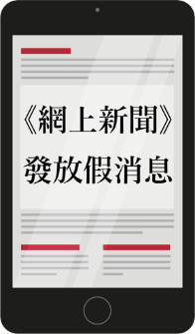

Online News

Disseminated fake news

**A boy stormed the whole city by making use of a news medium to post false news**

In 2003, a 14-year-old boy changed the format of an online news medium and spread rumours on the Internet, falsely claiming that the Chief Executive announced that “Hong Kong has become an epidemic port”. He uploaded the false news to his website, causing public panic. In the end, the boy was prosecuted by the police for committing offences under the Quarantine and Prevention of Disease Ordinance.

**A rumour maker arrested! He disseminated false information about many employees of a shopping mall having fever**

In 2020, a man who worked as a part-time security guard in a shopping mall was suspected of disseminating false information on a social media platform. He claimed that many employees of the shopping mall had fever and asked for sick leave, trying to exaggerate the Covid-19 pandemic and cause panic among the public. After investigation, the man was arrested for using a wireless phone to transmit fake information.

Arrested!

Someone disseminated fake news about Covid-19

Source: 舊時香港 (2018), 1 April 2003 is an unforgettable April Fool’s day for Hong Kong people; Hong Kong Police Force [Twitter Official account] (2020).



Appendix 4

**Know more: Laws of Hong Kong related to media use: Some examples**

1. **Summary Offences Ordinance**

**Section 20 Offences in connection with telephone calls or messages or telegrams**

Any person who

1. sends any message by telegraph, telephone, wireless telegraphy or wireless telephony which is grossly offensive or of an indecent, obscene or menacing character; or
2. sends by any such means any message, which he knows to be false, for the purpose of causing annoyance, inconvenience or needless anxiety to any other person; or
3. persistently makes telephone calls without reasonable cause and for any such purpose as aforesaid,

shall be liable to a fine of $1,000 and to imprisonment for 2 months.

1. **Section 27a Cap. 106 Unauthorized access to computer by telecommunications**

Any person who, by telecommunications, knowingly causes a computer to perform any function to obtain unauthorized access to any program or data held in a computer commits an offence and is liable on conviction to a fine at level 4*.

1. **Section 161 Cap. 200 Access to computer with criminal or dishonest intent**

Any person who obtains access to a computer

1. with intent to commit an offence;
2. with a dishonest intent to deceive;
3. with a view to dishonest gain for himself or another; or
4. with a dishonest intent to cause loss to another,

commits an offence and shall be liable to imprisonment for 5 years.

1. **Section 64 Privacy Ordinance**

This section specifies that a person commits an offence if the person discloses any personal data of a data subject which was obtained from a data user without the data user’s consent, with an intent

1. to obtain gain in money or other property, whether for the benefit of the person or another person; or
2. to cause loss in money or other property to the data subject; or
3. the disclosure causes psychological harm to the data subject.
4. **Section 5 Cap. 21 Defamation Ordinance**

Any person who maliciously publishes any defamatory libel, knowing the same to be false, shall be liable to imprisonment for 2 years, and, in addition, to pay such fine as the court may award.

* Fine at Level 4 is $25,000

Source: Hong Kong e-Legislation (2019).

**Module 1.1 Self-understanding and Life Skills**

**Part 4: Media and Information Literacy**

**(Lesson 3 and Lesson 4)**

The teacher shall ask students to finish Worksheet 3 before the class first and then carry out a discussion activity and conclude the key points during the class.

**Learning and Teaching Materials:**

**Worksheet 3: Media and information literacy**

**I was selected as the world’s most influential person of the year by TIME?**

Every year, TIME selects the world’s most influential person, event or thing of the year. In 2006, you defeated a number of strong competitors and became the world’s most influential person of the year. Because you controlled the information age, brought hundreds of billions of pieces of rich information to netizens, including pictures, words, videos and audios, and pushed the world towards the Internet age.

**Activity 1: What is media and information literacy?**

Internet media has developed rapidly. We have been changed from passive media information receivers to creators gradually. We begin to write media content creatively, share what we have seen, heard and thought, gradually promoting the era of “everyone is the media”. Due to the flooding of media information, media supervision is more difficult than before, which leads to a mix of good and bad contents of the media. As a result, negative impacts will be brought to us and society at any time. Therefore, it is **very important** to nurture **media and information literacy**.

Students watch the “‘3-minute Concept’ animated video clip series: Media and information literacy” and complete the questions before the class. The teacher can watch this video clip with students again during the class and discuss this worksheet.

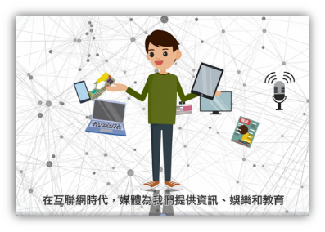Do you know what is media and information literacy? Watch the “‘3-minute Concept’ animated video clip: Media and information literacy” carefully and then answer the following questions.

 “3-minute Concept” animated video clip series: Media literacy

https://www.edb.gov.hk/tc/curriculum-development/kla/pshe/references-and-resources/life-and-society/3-min-concept.html

1. **Fill in the blanks**

**Fill in the blanks with correct answers.**

Media literacy includes:

*Analysing*

**Media and Information Literacy**

Media information

*Creating*

*Creating*

Media contents

1. **True or False**

**Determine which of the following statements are true and which are false and put a “T” if a statement if true and a “F” if a statement is false.**

|  |  |  |
| --- | --- | --- |
|  | The media brings us convenience and fun, but it also influences our values and views on things. | *T* |
|  | In this era which is pursuing “fast”, “interesting” and “new” in everything, all information is released after rigorous verification. | *F* |
|  | We should “Stop”, “Read”, “Listen” and “Care” whenever we receive and use media information or create media contents. | *T* |

1. **Short answers**

**If we want our media contents to be more valuable and appreciated by more people, what should we consider while creating media contents?**

|  |
| --- |
| *While creating media contents, we should think more about others’ feelings from* |
| *their perspectives.* |

**Activity 2: Nurturing media and information literacy**

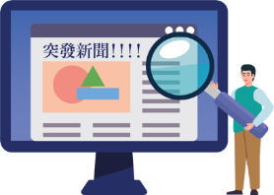**Media and information literacy** includes the ability to analyse, use and create media information.

**Analyse media information**

While receiving media information, we should

1. **Examine, analyse and rationally evaluate information contents**

* We should examine, analyse and rationally evaluate the authenticity, credibility and appropriateness of information contents; for example, whether the sources of the comments, data and photos are indicated; and whether the sources are credible; and whether there is any supporting evidence provided by reputable organisations.

Shocking inside story:

Some netizens took pictures of a shop selling counterfeit backpacks! The photo is the truth! **(Already FC)**



* We should examine, analyse and rationally evaluate whether the contents of information are biased, misleading or fraudulent; and the values, orientation and position of the contents of information.



* We should examine, analyse and rationally evaluate the motives of people who post the information.

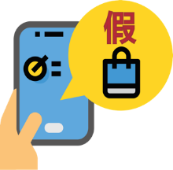

**Fake**

* Are the contents of information/photos true?
* Are the sources of information/photos credible? Do they come from reputable sources?
* If the person who posted the information claims that the information/photos have been fact checked, will they be definitely true?
* What are the motives of authors for posting articles?

**FC:** FC stands for Fact Check. It refers to facts that can be checked. The sources of information and is contents (such as dates, places, persons, description of the events, etc.) need to be confirmed, for example, whether it comes from reputable organisations such as government departments, credible media, first-hand accounts of events, etc.

1. **Notice that the contents of media information or our attitudes of receiving information will affect or even mislead us**

The contents of media information or our attitudes of receiving information will generate some effects that will affect our judgement or even mislead us. Here are the effects proposed by some scholars. Please fill in a proper effect selected from the dotted box below in each space.

**Echo chamber effect Herding behaviour**

**Dunning-Kruger effect Network deregulation effect**



Social psychologists Dunning and Kruger have found that people with poor abilities will indulge in self-constructed superiority, overestimate their ability and pretend to be experts to gain superiority that they can’t achieve in real life. There are also many “pseudo experts” of this type on the Internet. In fact, people with a higher level of knowledge will think that they are not good enough and tend to learn and be careful in their words and deeds.

This refers to the situation that people will often choose the decisions or opinions of the majority as their own choices because they are unable to think independently under the circumstances that there is no sufficient information and the situations are unclear. Individuals are easily influenced by peers and social media. For example, many participants of cyberbullying actually do not understand the cause of the events that they have participated in, or even think that they have not been part of the events. They just follow the public’s opinions and practices.



Expert

This refers to the situation that Internet users tend to communicate about media information received in circles or platforms close to their own opinions and refuse to accept the stands of other opinions, with a view to finding “echo” for their own opinions. This effect makes Internet users indulge in the circles of similar positions, refuse the exchange of rational and different views and receive single and

one-sided information flow,

which will hinder their

understanding of things and

formation of fair and objective

views.

Psychologist John Suler has found that more and more netizens begin to attack, provoke and curse merely based on the titles of articles without reading their contents. They lack empathy and respect, which makes the Internet as a whole full of hostility and recklessness.

Scholars have pointed out that the immediacy and anonymity of the Internet encourage netizens to behave differently from what they will behave in real life and ignore social norms and responsibilities.



1. **Stay rational and make judgement or take action without being affected by emotions**

We should be careful about provocative information and don’t make any judgement or take any action when we are emotional. Generally, we make wise judgements or take wise actions only when we think rationally.

**Activity 3: Nurturing media and information literacy: Case study**

Read this social media post carefully and answer the following questions:

**Case**

**Social media post**

**Don’t oblige the devil and take part in boycott movement**

It was said by all our group members that the owner of Restaurant A skimped on the employees’ wages and benefits and was an unscrupulous employer. If you don’t believe me, you can check the post of the group!

I can tell from his appearance that he is a not a good man!

For the sake of justice and the employees, many people have answered to the call and anonymously attacked Restaurant A’ s website on the Internet and boycotted it. If you don’t join us, you will be a vampire who supports labour exploitation!

Please spread it widely!



1. Is this post true? How would you verify whether the contents are true?

|  |
| --- |
| *Suggested answer:*   * *The post may not be true. It must be verified (Fact Check). I will identify the source of the information first. And then, I will check whether the contents of the post in the group is true or whether they are biased or misleading and the accuracy of the date or time. Finally, I will check whether there are relevant comments and information provided by reputable organisations. If there is no information from credible sources for verification, I will not believe that the contents of this post are true.* |

1. Are there biased contents in this post? If so, what are they?

|  |
| --- |
| *Suggested answer:*   * *Yes, the author judged the restaurant owner is not a good man only by his appearance and then encouraged the public to boycott the restaurant, which was not objective and lacked scientific evidence. The motives behind of the author are suspicious.* |

1. The author pointed out that those who disagreed with him were supporters of labour exploitation. Do you agree? What do you think are the motives of the above statements?

|  |
| --- |
| *Suggested answer*   * *I don’t agree. We can’t make any judgement based on one-sided statements. If the employer is accused of conducting suspected illegal acts, such as labor exploitation, we should report it to and seek help from relevant government departments. The motives of the author disseminating the above statements might be that he/she wanted to target at the owner with the intention of revenge, harassment and attack. By doing so, he hoped that his purpose could be achieved with pressure from the public.* |

1. Refer to the Internet media information related effects that were put forward by scholars in Activity 2. How does this post display these effects? Try to provide relevant examples in the table below for illustration.

|  |  |  |
| --- | --- | --- |
|  | **Effects** | **Examples** |
|  | Echo chamber effect | *Suggested answer:*  *People posted messages to echo the author’s view that the public should boycott the restaurant as a way of upholding justice. Besides, they echoed the author’s view that those who would not join the boycott action as vampires who supported labour exploitation. In doing so, they tend to build up a critical mass of people with the similar views.* |
|  | Herding behaviour | *Suggested answer:*  *People who posted messages believed the statements of the group members, followed the position of the group, and even called on more people to “uphold justice” together.* |

|  |  |  |
| --- | --- | --- |
|  | Dunning-Kruger effect  Expert | *Suggested answer:*  *The author took on the role of expert, claiming that he could tell whether a man was good or bad by his appearance and that the restaurant owner was exploiting labour and calling on people to boycott his restaurant.* |
|  | Network deregulation effect | *Suggested answer:*  *Taking advantage of the anonymity of the Internet, the author published and advocated behaviours that he wouldn’t dare to do in real life, such as slandering, calling for boycotting the restaurant owner in the name of justice, etc.* |

1. Do you think it was rational that the author of the post said that netizens should all boycott Restaurant A for the sake of justice and the employees? If the employees are exploited, is there any other better way to help them?

|  |
| --- |
| *Suggested answer:*   * *It was irrational. Boycotting might not be a good way that could solve all the problems and it might even affect the livelihood of other employees. Netizens should advise the exploited employees to seek assistance from the Labour Department and deal with this matter in a rational and legal way.* |

1. This post has conveyed some negative values/attitudes. Try to provide relevant examples in the table below. You can also provide your personal opinions together with examples in the column of “Others”.

|  |  |  |
| --- | --- | --- |
|  | **Negative values/attitudes** | **Examples** |
|  | Prejudice, discrimination and judging by appearance | *Suggested answer:*  *The author judged whether the owner was good or bad only by his appearance; regarded those who would not join the action as vampires who supported labour exploitation.* |
|  | Subjectivity, blindness and unitarity | *Suggested answer:*  *The author subjectively thought that the employer exploited the employees; blindly believed the information provided by the group; was unitary in thinking and thought that boycotting was the only way to solve the problems.* |
|  | Self-centeredness | *Suggested answer:*  *The author was self-centred. He imposed his own ideas on others. He thought that the owner was a bad person and an unscrupulous employer; and regarded those who would not participate in the boycott movement as vampires who supported labour exploitation.* |
|  | Irrationality and extremism | *Suggested answer:*  *The author didn’t choose to take rational or positive methods to solve the problems first but called on the people to attack and boycott the restaurant. These were irrational and extreme behaviours, which could cause troubles and harms to others easily.* |
|  | Others: |  |

1. Put a tick “✓” to indicate the values that you think this post has ignored.

|  |  |  |  |
| --- | --- | --- | --- |
| ☑Equality | □Sustainability | □Perseverance | □Diligence |
| ☑Rationality | □Trust | ☑Integrity | □Optimism |
| ☑Empathy | ☑Respecting others | ☑Responsibility | □Openness |
| □Overall well-being | □Cultural heritage | □Diversity | □Cooperation |

1. Do you think the contents of this post are appropriate? Will you forward it? Why?

(Hint: you can judge whether the contents are appropriate from the values conveyed in this post.)

|  |
| --- |
| *Suggested answer:*   * *The contents are inappropriate. Because the information is not verified (FC) and the author had impure motives. The author ignored the values of equality, rationality, empathy and so on and conveyed the attitudes of extremism, discrimination, subjectivity, and others. I will not forward or comment on this post without substantial evidence or when there are biases, so as not to go wrong or become an accomplice.* |

**Use and create media information**

While using and creating media information, we should bear in mind that we should use media contents properly and effectively, distinguish between right and wrong, maintain a sense of empathy and responsibility, and avoid immoral behaviours. In addition, the Internet media contents can be accessed and spread very easily and everyone who posts may become an example for others. Therefore, we should post contents after careful consideration and rational analysis; otherwise we will bring negative impacts to others and society.

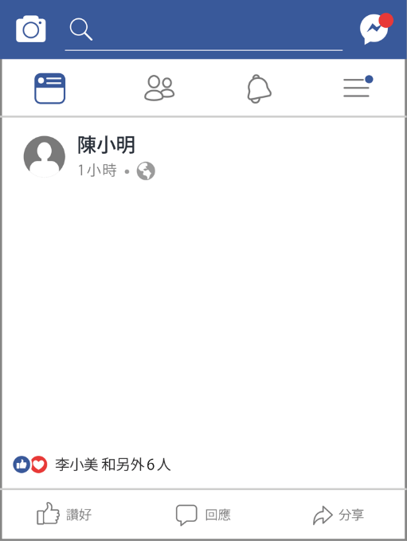

[Live stream traffic accident]

I’m so lucky to have witnessed a severe car accident of the century! I must take more photos to commemorate it!

I took good pictures, right? Remember to ‘LIKE’ my pictures, especially my selfie, haha!

**Case**

* **Do you think the author of the post has empathy? Why?**
* **Do you think the author is responsible for what he has written in the post? Why?**

Read this social media post carefully and answer the following questions:



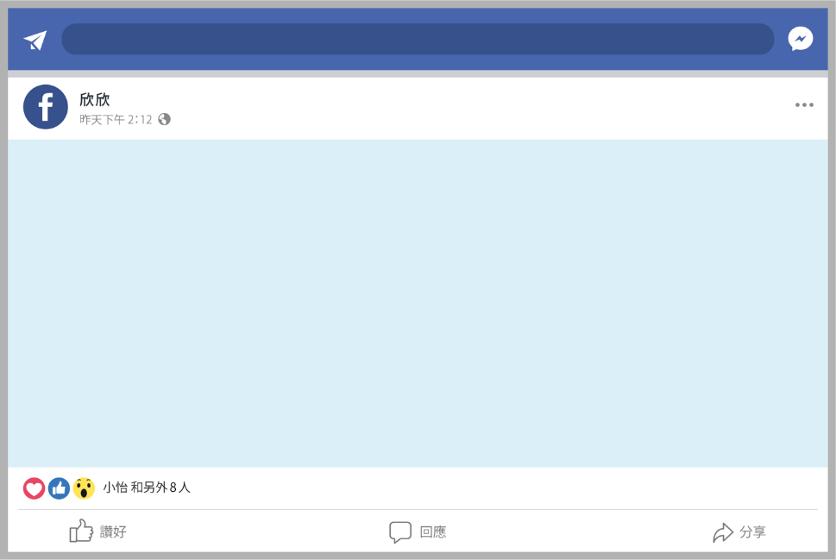

**Social media post**

**Those who use their heads won’t be short of money**

Want to buy something? Just move your fingers and we will send you the money!

As long as you use your creativity and upload posts to like the electronic products of a certain brand, you will be paid HK$ 5 for each post which receive more than 50 likes or comments and HK$ 40 for 300 likes and comments, and so on. The more you post, the more you earn.

Send me a private message if you are interested! 

Share

Comment

Like

1. What do you think are the purposes/motives of the author of this post?

|  |
| --- |
| *Suggested answer:*   * *The purposes/motives of the author are to attract netizens to upload posts to praise the products and create a certain amount of positive comments on the posts, with a view to making the products more visible to achieve the effect of promoting the products. Besides, he/she can also take this opportunity to collect people’s personal data for future marketing objectives* |

1. Taking posts about electronic products as examples, what problems will be caused by creating and posting false information?

|  |
| --- |
| *Suggested answer:*   * *People will easily fall into consumption traps because of the false information. Information receivers will wrongly use the amount of likes or comments to decide whether to buy the products or not. The posts raise people’s expectations and confidence in the products, which will make them pay less attention to product safety. And it will be too late for them to find that the product quality may not meet their expectations or even cause accidents.* |

1. This post has conveyed some negative values/attitudes. Try to provide relevant examples in the table below. You can also provide your personal opinions together with examples in the column of “Others”.

|  |  |  |
| --- | --- | --- |
|  | **Negative values/**  **attitudes** | **Examples** |
|  | Attaching importance to material possession | *Suggested answer:*  *It encourages people to do whatever it takes to buy things that they want.* |
|  | Giving priority to money | *Suggested answer:*  *It advocates that in order to make money, it is not necessary to think about the motives behind and personal integrity. People simply upload posts to praise the products which they have not used and the quality of the products is ignored.* |
|  | Seeking quick success and instant benefits | *Suggested answer:*  *It makes people think that the work is simple and everyone can make money by just moving their fingers. It misleads people to think that “seeking quick money” and “taking a shortcut” are the ways to satisfy their material desires and get rich.* |
|  | Getting something for nothing | *Suggested answer:*  *It makes people think that they can make a lot of quick money through simple methods.* |
|  | Fraudulence | *Suggested answer:*  *It lures netizens to upload posts on some products and give positive responses to the posts, so as to make consumers believe the products are worth buying and buy products with the result that they lose money in the end. It is also a fraud for netizens to upload posts to praise products that they have never used to earn money.* |
|  | Others |  |

1. Put a tick “✓” to each of the value that you think this post has ignored.

|  |  |  |  |
| --- | --- | --- | --- |
| □Simplicity | □Sustainability | □Perseverance | □Diligence |
| □Equality | □Trust | ☑Integrity | □Optimism |
| ☑Empathy | ☑ Honesty | ☑Responsibility | ☑ Rationality |
| ☑Overall well-being | □Cultural heritage | □Diversity | □Cooperation |

1. Do you think this post is misleading? What are the possible consequences?

|  |
| --- |
| *Suggested answer:*   * *Yes. This post misleads netizens that it’s easy to make money by simply moving their fingers and highlights “interests” and “simplicity” so as to make people believe that there is no severe consequence and participate in uploading posts. In the end, others may fall into consumption traps because of improper recommendations of products that are of poor quality or have safety problems.* |

1. Will you participate in creating and uploading posts? Why?

(Hints: you can judge whether you will participate in creating and uploading posts from the values conveyed in this post.)

|  |
| --- |
| *Suggested answer:*   * *No. If I upload posts to praise a product that I have never used, my behaviour will be no different from cheating other consumers.* * *I will not participate in creating and uploading posts without support of evidence or safety verification so as not to mislead other consumers or become an accomplice of consumption traps.* |

The teacher shall encourage students to study “Self-learning material 2: Strategy to deal with media information: the four steps of USER” by themselves.

**Activity 4: Strategy to deal with media information: Stop, Read, Listen and Care**

There are many kinds of Internet media information and it is easy to fall into traps if we are not paying careful attention. In order to safely and fully enjoy the convenience and fun brought by the media, we must learn the strategy “Stop, Read, Listen and Heart”. Thinking from the four aspects of this strategy will allow us to decide whether there are echo chamber effect, herding behaviour, Dunning-Kruger effect or Network deregulation effect affecting our judgements or behaviours while dealing with the media. As long as we think twice for everything, verify repeatedly, listen and ask more when we have doubts, know how to put ourselves in others’ shoes and think about others’ feelings, we can nurture good media and information literacy.

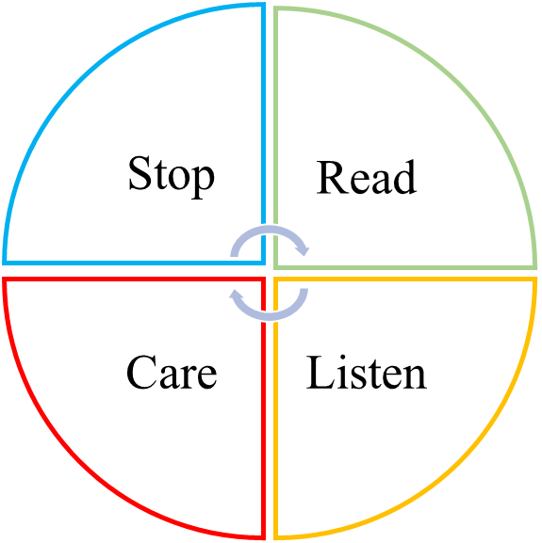

Stop to think about the authenticity, motives, values of information and what will be the impacts on others if we forward.

Read more relevant information and verify the information is true and accurate. Think carefully whether related information is biased or misleading

Be empathetic and responsible, consider others’ feelings from their perspectives and think about the impacts on the overall well-being of society while uploading, forwarding and creating media contents.

Listen more to the opinions, suggestions and experiences of different people and then carefully evaluate whether the information is trustworthy.



Source: Education Bureau, the government of the Hong Kong Special Administrative Region (2019), 〈Media Literacy〉. “3-minute Concept” animated video clip series (2019).

Read the following information carefully and then answer the questions below.

The teacher shall highlight key points in bold so as to help less able students to answer the questions. For students with high ability, there is no need to highlight key points in bold.

Source 1

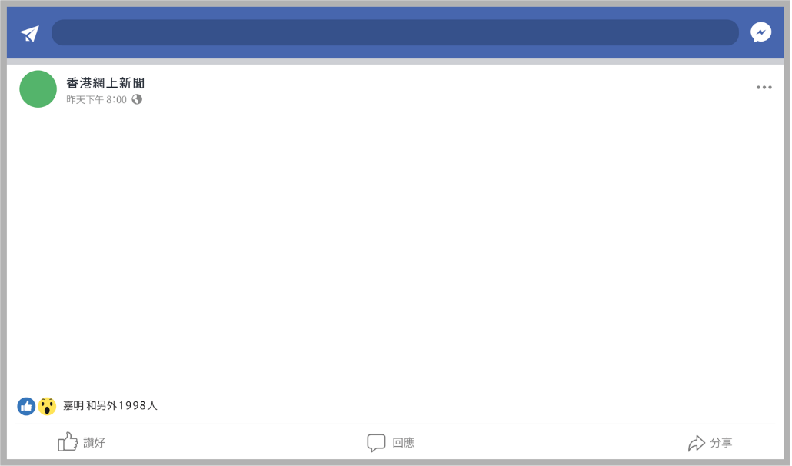

After a traffic accident, a picture of a taxi driver who **looks flushed** being lifted out of a vehicle was circulated on the Internet. **A post pointed out that the driver was drunk driving, which led to the serious traffic accident.** The post spread wildly on the Internet and **netizens criticised and even abused the driver with rude language**. Some netizens even **“disclosed the personal information” of the driver and his family on the Internet.** Besides, they also initiated a gathering near the place where the driver lived to harass and abuse his family. As a result, the driver and his family suffered a lot.

Like

Share

Comment

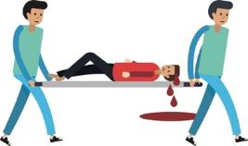

Source 2

Two days after the accident...

An expert of multimedia verified the authenticity of the picture on the Internet and found that the reason why the driver in the picture looked flushed was because it was a prank and the picture was “photoshopped”.



Source 3



Fake News

Three days after the accident...

News report: After several days of investigation, the police has confirmed that the taxi driver did not drink before the accident. Based on the road conditions, the cause of the serious traffic accident is likely to be the sudden overtaking of another vehicle, and since there was not enough time for the taxi driver to give way to that vehicle, the accident happened*.*

1. According to Source 1, what do you think are the problems of the behaviour of the netizens? Try to give three examples.

|  |
| --- |
| *Suggested answer:*   * *The netizen who uploaded the post were irresponsible and released false information.* * *The netizens who uploaded the posts deliberately made false evidence to mislead other readers, lacking integrity.* * *It was irresponsible for the netizens to forward the post without verifying the authenticity of this media information or rationally analysing the media contents.* * *The netizens took part in online bullying and online public trial, criticised the person concerned and even abused him with rude language without considering whether their behaviour was appropriate, lacking empathy and the ability to distinguish right from wrong.* * *The behaviour of “disclosing the personal information” of the person concerned invaded the privacy of the person and might commit offenses to the law, which reflected that the netizens were disrespectful to others and lacked empathy and legal consciousness.。* * *The netizens harassed and abused his family at places near to his home. They were violent and they didn’t consider the negative effects, such as emotional distress, might be brought to the person concerned and his family by their personal behaviours, lacking empathy.* |

1. Suppose you want to upload a post to help clear the rumour in Source 1 and correct the bad behaviours that you have listed in question 1 and tell netizens how to use social media positively. In this task, you will use **the strategy of “Stop, Read, Listen and Care”** to create your post with words, photos and/or **pictures** based on the information in Source 2 and Source 3.

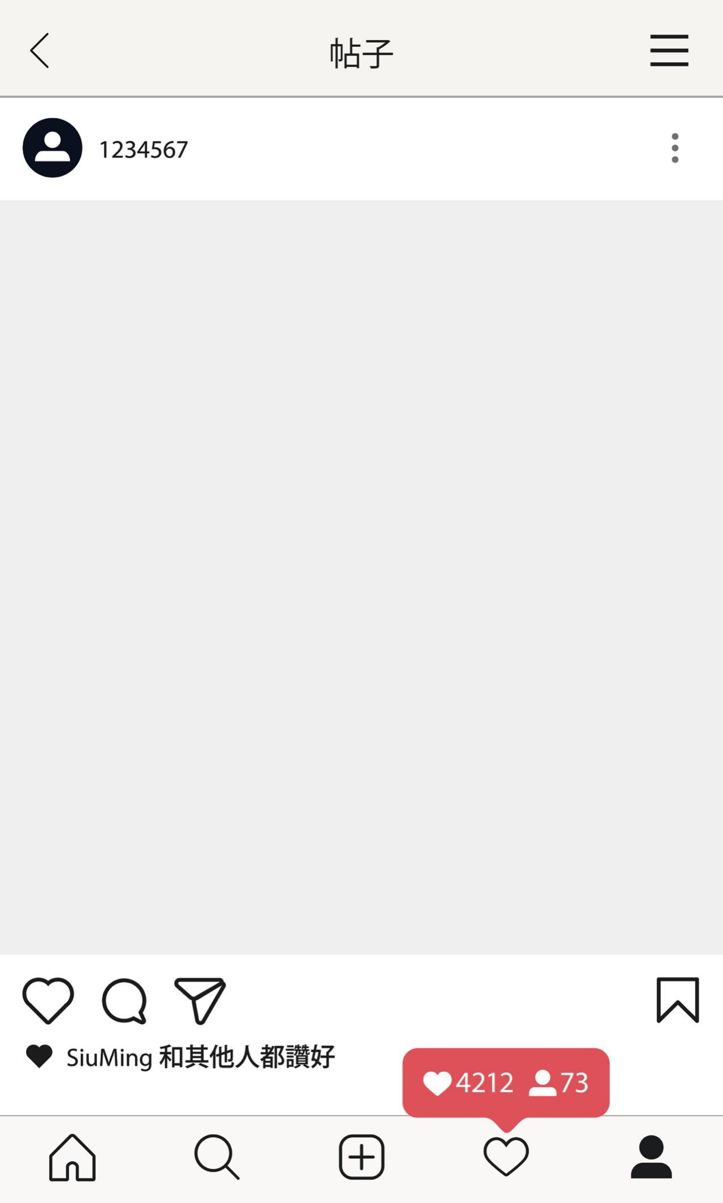

Post



*For example:*

*Please stop forwarding untrue posts and posting untrue statements!*

*Please see clearly. As confirmed by experts, the photo is photoshopped. The polic* *e also pointed out that it was very likely that the accident was caused by another vehicle which was overtaking. The following is a link to the relevant news report:*

*xxxxxxxxxxxxxxxxxxxxxxxxxxxxxxxxxxxxxx*

*xxxxxxxxxxxxxxxxxxxxxxxxxxxxxxxxxxxxxx*

*Stop hurting the innocent driver and his family!*

and others



**Conclusion**

As media technology is developing rapidly, the Internet is found in all areas of life. People are exposed to widely covered and rich information. Our daily work, lifestyle and social network are closely related to the media which has become indispensable. The media has brought all kinds of conveniences, but also many undercurrents. The advantage of Internet media is that all people can post. We upload all kinds of information to the Internet, which can influence people. With all kinds of information rushing in, we may easily feel confused and led to adopt the views conveyed by the media.

Compared with traditional media, people tend to hide their identities in Internet media. And since the Internet world is boundless, it seems that there is no regulation, which make people mistakenly think that they can say whatever they like because they don’t have to be responsible anyway. It’s easy to find “confidants” and “supporters” in Internet media; and when people post their views online and the views are echoed by these “confidants” and “supporters”, they will feel that their views are right and gradually can’t accommodate the views of others. People no longer discuss and analyse objectively. On the contrary, we attack those who hold different views, leading to the division between “me” and “you” and the belief that the “me” party is always right. Therefore, Internet media can become a venue for abuse, prejudices and contradictions.



Therefore, we need to nurture good media literacy. While dealing with the media, we should think carefully and seek in-depth verification so as not to be incited or misled by false information or news or allow them to affect our characters and behaviours.

But more importantly, we should keep thinking positive. While using the media, we should give priority to the values of responsibility and empathy, consider carefully the impacts of media contents on all walks of life, hold positive values and attitudes towards the use of the media, and try to a become good citizens who are responsible for the society, the country and the world. When everyone knows how to make use of the advantages of the media and make up for its shortcomings, we cannot only truly realise its value, but also resolve all kinds of contradictions and prejudices, thus achieving a harmonious and inclusive environment.

~~~~



Appendix 5

**Know more: Identifying false reports**

**10 official tips from Facebook to spot false news**

1. **Be sceptical of headlines:** False news stories often have catchy headlines in all caps with exclamation points. If shocking claims in the headline sound unbelievable, they probably are untrue.
2. **Look closely at the URL:** A phoney or lookalike URL may be a warning sign of false news. Many false news sites mimic authentic news sources by making small changes to the URL. You can go to the site to compare the URL with established sources.
3. **Investigate the source:** Ensure that the story is written by a source that you trust with a reputation for accuracy. If the story comes from an unfamiliar organisation, check their "About" section to learn more.
4. **Watch out for unusual formatting:** Many false news sites have misspellings or awkward layouts. Read carefully if you see these signs.
5. **Consider the photos:** False news stories often contain manipulated images or videos. Sometimes the photo may be authentic but taken out of context. You can search for the photo or image to verify where it came from.
6. **Inspect the dates:** False news stories may contain timelines that make no sense, or event dates that have been altered.
7. **Check the evidence:** Check the author's sources to confirm that they are accurate. Lack of evidence or reliance on unnamed experts may indicate a false news story.
8. **Look at other reports:** If no other news source is reporting the same story, it may indicate that the story is false. If the story is reported by multiple sources that you trust, it's more likely to be true.
9. **Is the story a joke?** Sometimes, false news stories can be hard to distinguish from humour or satire. Check if the source is known for parody and if the story's details and tone suggest that it may be just for fun.
10. **Some stories are intentionally false:** Think critically about the stories you read, and only share news that you know to be credible.

Excerpted and adapted from: Facebook (2020), Tips to Spot False.



**Joyful reading**

**What is the Internet?**

It has been mentioned in this topic that “With the coming of the information age, the Internet has been widely used and popularised, followed by the vigorous development of Internet media”. Do you know what the Internet that we can hardly live without is? The Khan Academy of the U.S. has made a 3-minute English teaching video, in which it has introduced what the Internet is in an interesting way. You can try to click the following website address to watch the video.

https://www.khanacademy.org/computing/computer-science/computers-and-internet-code-org/internet-works-intro/v/what-is-the-internet

The following is the transcript of the video mentioned above, which is provided to help you to understand the contents of the video.

|  |
| --- |
| **What is the Internet?**  Transcript    The Internet is like a popular thing.  Some satellites up there.  I picture it in my head with like waves of Internet going to the phone.  Somebody told me a cloud once.  The Internet is a lot like plumbing. It’s always moving.  Most people don’t have any idea where the Internet came from and  Doesn’t matter, they don’t need to. It’s sort of like asking who invented the ballpoint pen, or the flush toilet, or the zipper.  These are all things we just use every day. We don’t even think about the fact that one day somebody invented them.  So the Internet is just like that.  Many, many years ago in the 1970s, my partner Bob Kahn and I began working on the design of what we now call the Internet.  It was a result of another experiment called the ARPANET,  which stood for Advanced Research Project Agency Network. |
| It was a (U.S.) Defense Department research project.  Paul Baran was trying to figure out how to build a communication system that might actually survive a nuclear attack.  So he had this idea of breaking messages up into blocks and sending them as fast as possible in every possible direction  Through the Mesh Network.  So we built what eventually became a nationwide experimental packet network, and it worked.  Is anybody in charge of the Internet?  The government controls it;  Elves, obviously elves;  The people to control the Wi-Fi because then no Wi-Fi, no Internet;  T-mobile, um, Xfinity，  Bill Gates  Right?  The honest answer is...well, nobody and maybe another answer is everybody.  The real answer is that the Internet is made up of an incredibly large number of independently operated networks.  What’s interesting about the system is that it’s fully distributed.  There’s no central control that is deciding how packets are routed or where pieces of the network are built, or even who interconnects with whom.  These are all business decisions that are made independently by the operators.  They are all motivated to assure that there is end-to-end connectivity of every part of the network.  Because the utility of the net is that any device can communicate with any other device,  just like you want to be able to make phone calls to any other telephone in the world.  There’s nothing like this that has ever been built before.  The idea that what you know might be useful to somebody else  or vice versa is a very powerful motivator for sharing information.  By the way that’s how science gets done:  People share information.  So this is an opportunity for people to think up applications,  maybe program them as apps on a mobile phone,  maybe become part of the continued growth of the infrastructure of the network  to bring it to people who don’t have access to it yet, or just make use of it on a day-to-day basis.  You can’t escape from contact with the Internet so why not get to know it and use it. |

Reflective questions:

1. Do you have a deeper understanding of the Internet now? Try to name one new knowledge about the Internet that you learned from the video.
2. CHING Pak-chung, a Chair Professor of electronic engineering of the Chinese University of Hong Kong, once observed that without optical fibre, there wouldn’t be Internet popularization. “In the age of the Internet, we should always remember ‘his’ contribution.”. Do you who “he” is? He is GOU Kwan, a Nobel Prize laureate in Physics and the third Vice-chancellor of the Chinese University of Hong Kong. His life and achievements in scientific research are worth learning. You can go to the library or search the Internet to find the stories of Professor GOU Kwan and learn from him.



Self-learning materials

**Self-learning material 1: The media is closely related to us**

**Quiz on Internet media use behaviours**

The following quiz can help you better understand your habits of using Internet media. Recall how you used Internet media in the past week and give a score to each of the items in the following table. **The highest score is 10 (used it many times or used it frequently in one day) and the lowest score is 0 (never used).**

|  |  |
| --- | --- |
| Forms | Scores |
| 1. Instant communication/chat |  |
| 1. Making new friends online |  |
| 1. Browsing the news of friends |  |
| 1. Checking emails |  |
| 1. Reading current events online |  |
| 1. Reading entertainment news online |  |
| 1. Watching TV series/TV programs/movies online |  |
| 1. Reading novels/comics online |  |
| 1. Playing games online |  |
| 1. Browsing websites |  |
| 1. Learning online (for example: completing homework, discussing homework, watching or listening to learning contents, etc.); self-learning new knowledge (for example: cooking, handicraft, photography, science, etc.) |  |
| 1. Collecting/searching information online (for example: transportation, weather, environment, disasters, accidents, etc.) |  |
| 1. Shopping online (for example: clothes, shoes and socks, daily supplies, air tickets, etc.) |  |
| 1. Booking seats/theatre tickets/food delivery online |  |
| 1. Updating personal information |  |
| 1. Uploading photos, music or movies |  |
| 1. Sharing personal views (for example: writing blog, sharing travel information, food, etc.) |  |
| 1. Commenting online |  |
| 1. Live broadcasting |  |
| 1. Others: *(please provide)* |  |

Questions for discussion:

With reference to the above and your personal views, answer the following questions:

1. According to the above quiz, fill in the “Nos.” given to related media use behaviours corresponding to their functions and then calculate the total scores for your media use behaviour.

|  |  |  |
| --- | --- | --- |
| **Media use behaviours** | | **Total scores of media use behaviour** |
| **Functions** | **Numbers** |
| Life conveniences (clothing, food, housing, transportation and shopping) | For example: 14, 15 |  |
| Education | *11, 13* |  |
| Life information | *6, 10, 12* |  |
| Entertainment | *7, 8, 9, 17* |  |
| Social interaction | *1, 2, 3, 4, 16, 17, 18, 19, 20* |  |
| Current events of society | *5* |  |

1. According to Question 1, you get the top three scores in which 3 types of media use behaviours? Which functions of Internet media do you mainly use?

|  |
| --- |
| *For example:*  *I got my top 2 scores in entertainment and social interaction. It reflects that I mainly use the entertainment and social interaction functions of the media.* |

1. With the conveniences brought by the development of Internet media, our life has changed and we begin to rely on the Internet, with which our usage of traditional media is gradually changed. Try to find out how the elders carry out the following activities in the age of traditional media by searching the Internet or asking the elders and then fill in the table below.

|  |  |
| --- | --- |
| **In the age of Internet media** | **In the age of traditional media** |
| Instant communication/chat | Examples: letters, notes, phones, pagers, text messages |
| Making new friends online | *Introduced by friends, friends wanted ads in newspapers and magazines* |
| Browsing the news of friends | *Personal contact, letters, phone calls, enquiring others* |
| Checking emails | *Letters, faxes* |
| Reading current events online | *Newspapers, magazines, radio, TV* |
| Reading entertainment news online | *Newspapers, magazines, radio, TV* |
| Watching TV series/TV programs/movies online | *TV, cinemas, renting videos* |
| Reading novels/comics online | *Going to libraries, bookstores, comic shops in person* |
| Playing games online | *Toys, portable game machines, game centres* |
| Browsing websites | *Newspapers, magazines, radio, TV, wall mounted advertisements* |
| Learning online (for example: completing homework, discussing homework, watching or listening to study contents, etc.); studying new knowledge by oneself (for example: cooking, handicraft, Photography, science, etc.) | *Textbooks, homework, telephone discussion, face-to-face discussion, face-to-face teaching, educational TV programs, teaching CD-roms, hiring tutors, reading books, taking classes in school* |
| Collecting/searching information online (for example: transportation, weather, environment, disasters, threads, etc.) | *Libraries, on-the-spot data collection, letters, faxes, telephone enquiries, TV and radio release* |
| Shopping online (for example: clothes, shoes and socks, daily supplies, foods, plane tickets, etc.) | *Buying in physical stores, booking by calls, agency purchase, in print or sales advertisements* |
| Booking seats/theatre tickets/food delivery online | *Purchasing in person, booking by calls, agency purchase* |
| Updating personal information | *Updating in person* |
| Uploading photos, music or movies | *Photo album, gramophone, CD player, Walkman, acoustic equipment, recorder* |
| Sharing personal understandings by writing blogs (for example: travel, food) | *Diaries, phone calls, record manuals, parties* |
| Commenting | *Letters, faxes* |
| Online live broadcasting | *TV and radio broadcasting* |

**Self-learning material 2: Strategy to deal with media information: the four steps of USER**

When receiving and disseminating media information, we can use the four steps of USER to process information with an attitude of rigorous verification to ensure the authenticity, credibility and integrity of media contents. We also need to clearly understand the values contained in information and the impact of it on ourselves or others. We should get used to checking the sources of information actively to see whether they have credibility or official verification. Meanwhile, we also need to distinguish whether pieces of media information are facts or personal positions. Distinguishing information clearly helps to establish correct attitudes and analytical skills in dealing with the media. While encountering unconfirmed information, you can check it according to the following steps:

**Understanding:** While receiving a piece of information, think about the background and meaning of it.

**Source of information:** From whom, where and when did I receive this information?

**Search:** Search the source of information

**Credibility:** Who posted/made this information?

**The position and orientation of the media information:** What beliefs are conveyed in its purposes and position?

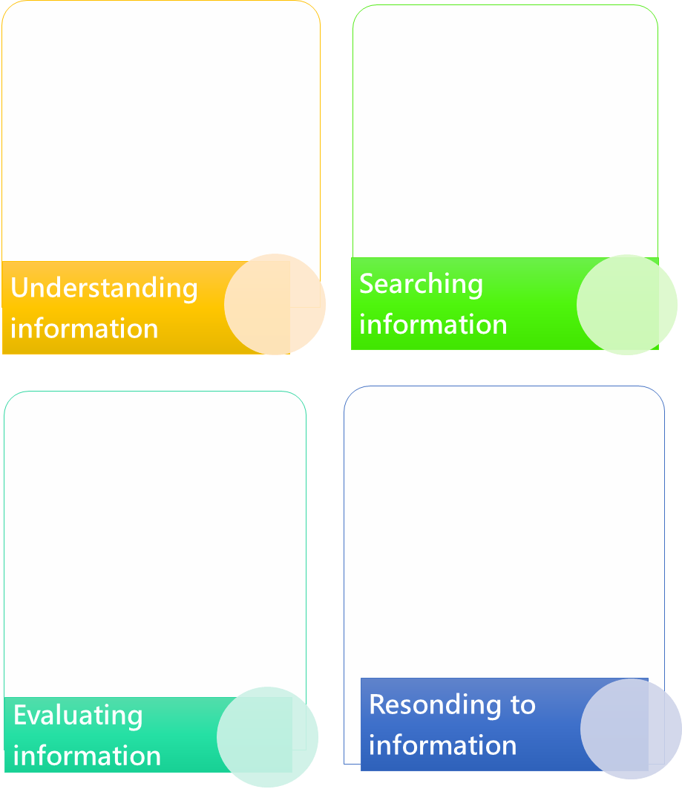

**Response:** Be aware of your responsibilities while responding to information.

**Authenticity, credibility and appropriateness:** Why is this information widely spread? Before I forward this information, do I understand, know about and agree with this meaning?

**No bias, misleading or fraud:** What are the effects of this information on ourselves, others and society?

**Evaluation:** Evaluating the effects brought by the information

**Motives:** Why is this information widely spread?

**Values conveyed:** What are the values and ideas conveyed by this information?

Excerpted and adapted from: Hong Kong Federation of Youth Groups (2017), New media

literacy textbook information kit.

**True or false, do you "know or not"?**

Please read the following contents carefully. Have you ever doubted the authenticity of information? If so, circle the part which you doubt about its authenticity? Why?



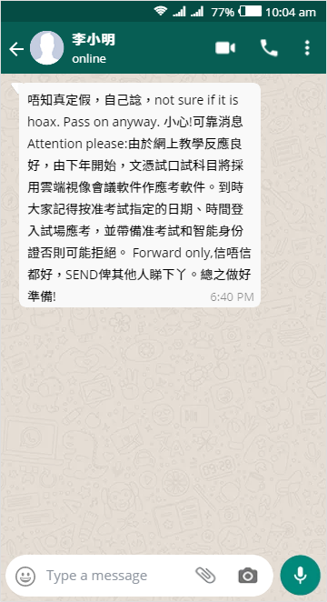

*Suggested answer*

I don’t know whether it is true. Just figure it out by yourself！

Reliable information: Due to the good response of online teaching, this semester’s exam will adopt the mode of open book cloud video meeting. That is to say, we don’t need to review and can refer to books during the exam. The most important thing is that there are good responses to this mode of exam.

Anyway, if you want to help your friends, send it to them and let them decide whether they believe it or not!

I generally/extremely/absolutely doubt/do not doubt the authenticity of the contents*, for the following reasons:

|  |
| --- |
| *For example:* |
| *It is unofficial; it seems like a boring* |
| *joke.* |

*\*Delete whichever is not applicable.*

Analyse the authenticity of the following contents with the four steps of USER according to the above contents.

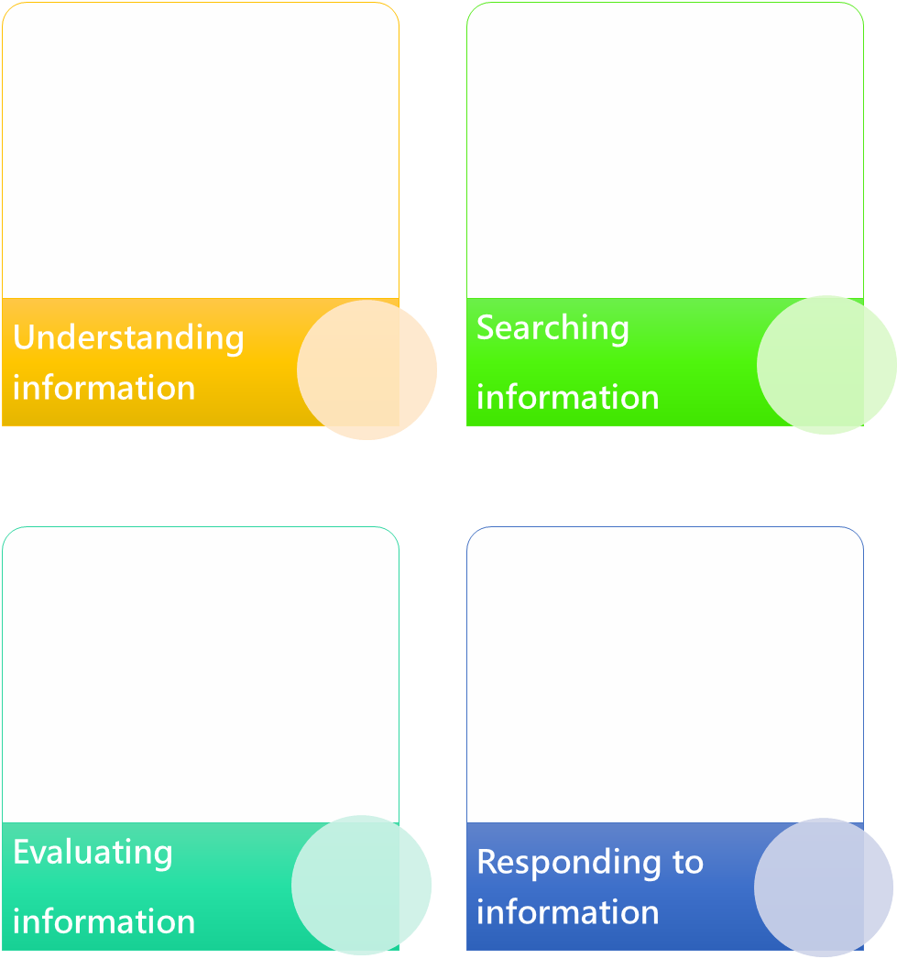

**Search:**

**Understanding:**

*For example:*

* *Is the information true and complete? Due to the lack of sources and verification from other authoritative persons or organisations of LEI Siu-ming’s information, it may not be a piece of complete information.*

*For example:*

* *Who posted this information? LEI Siu-ming posted it.*

**References**

*For example:*

* *I will not pay attention to or forward this information so as not to mislead others. I will check the source, authenticity and credibility of this information, such as asking teachers verify it.*

**Response:**

**Evaluation:**

*For example:*

* *What will be the impacts of the contents of this information on the persons concerned? Students will mistakenly think that it is true and take the exam without studying hard.*

LEI Pui-man (14 September 2019). Being insatiable + Retreating for advance They are skilful in online love scams (《得寸進尺+以退為進 網戀騙局偷心有術》). https://ol.mingpao.com/ldy/cultureleisure/culture/20180914/1536863447046/得寸進尺-以退為進-網戀騙局偷心有術

Ming Pao (27 October 2017). A restaurant in Yuen Long is accused of selling dog meat--Owner’s wife feels wronged: we clarified that it was mutton at the beginning of the year. (《元朗食肆被指劏賣狗肉⎯老闆娘稱被屈：年初已澄清過是羊》).   
https://news.mingpao.com/ins/港聞/article/20171027/s00001/1509102141210/元朗食肆被指劏賣狗肉-老闆娘稱被屈-年初已澄清過是羊

Oriental Daily (11 May 2017). After 70 hours’ hunting, the criminal of the rape and robbery case was arrested in Kowloon Bay (《九龍灣姦劫追兇70小時橋底色魔落網》).   
https://orientaldaily.on.cc/cnt/news/20170511/00174_001.html

Oriental Daily (28 October 2017). Owner of the restaurant which is accused of selling dog meat said it was mutton (《網傳食店賣狗肉 東主喊冤稱羊肉》). https://orientaldaily.on.cc/cnt/news/20171028/00176_092.html

Sing Tao Daily (7 October 2016). It is said online that the monthly income of a CSSA household of 4 is HK$22,000. The Social Welfare Department clarified: it is only HK$14,000 (《網傳4人家庭綜援月入2.2萬元，社署澄清：平均每月1.4萬元》) https://std.stheadline.com/instant/articles/detail/244407/%E5%8D%B3%E6%99%82-%E9%A6%99%E6%B8%AF-%E7%B6%B2%E5%82%B34%E4%BA%BA%E5%AE%B6%E5%BA%AD%E7%B6%9C%E6%8F%B4%E6%9C%88%E5%85%A52-2%E8%90%AC%E5%85%83-%E7%A4%BE%E7%BD%B2%E6%BE%84%E6%B8%85-%E5%B9%B3%E5%9D%87%E6%AF%8F%E6%9C%881-4%E8%90%AC%E5%85%83

Hong Kong Observatory (HKO) (24 September 2019). True. Uncle took pictures of a typhoon eye from a plane (《真．Uncle從飛機拍到颱風》). https://www.facebook.com/hk.observatory/photos/a.1635879299836036/2419261811497777/?type=3&theater

Hong Kong Federation of Youth Groups (2017). New media literacy textbook information kit (《新媒體素養教材資源套》). Hong Kong: Hong Kong Federation of Youth Groups.

Education Bureau, the government of the Hong Kong Special Administrative Region (2019).〈Media Literacy〉. “3-minute Concept” animated video clip series (2019).   
https://www.edb.gov.hk/tc/curriculum-development/kla/pshe/references-and-resources/life-and-society/3-min-concept.html

郝雨（2015）。《中國媒介批評學（上）》。中國：上海大學。

Hong Kong e-Legislation (12 December 2019).   
https://www.elegislation.gov.hk/

Department of Information and Technology of Education, Ministry of Education Republic of China (Taiwan) Network literacy and cognition in primary and secondary schools (《中小學網絡素養與認知》).

https://eteacher.edu.tw/Categorized.aspx

舊時香港 (31 March 2018). 1 April 2003 is an unforgettable April Fool’s day for Hong Kong people (《2003年4月1日是一個港人難忘的愚人節》) https://www.facebook.com/oldhkstory/posts/2054498194577548/

Bowman, S., & Willis, C. (2003). *We media. How audiences are shaping the future of news and information*. Reston, VA: The Media Center at the American Press Institute.

Facebook.com. (2020). *Tips to Spot False* https://www.facebook.com/help/188118808357379

Hong Kong Police Force [Twitter Official account] (4 February 2020). https://twitter.com/hkpoliceforce

Lazer, David M. J., Baum, M. A., Benkler, Y., Berinsky, A. J., Greenhill, K. M., Menczer, F, Metzger, M. J., Nyhan, B., Pennycook, G., Rothschild, D., Schudson, M., Sloman, S. A., Sunstein, C. R., Thorson, E. A., Watts, D. J., & Zittrain, J. L. (2018). The science of fake news. *Science, 359*, 1094–1096.

Levenson, P. (2009). *New new media*. Boston, MA: Allyn & Bacon.

Merskin, D. L. (2019). *The Sage international encyclopedia of mass media and society*. Thousand Oaks, CA: SAGE.

Rayson, S. (2017). We analyzed 100 million headlines. Here’s what we learned (New research). *BuzzSumo*. https://buzzsumo.com/blog/most-shared-headlines-study/

Time (2006, December 25). *Person of the Year: You*. http://content.time.com/time/covers/0,16641,20061225,00.html

**(Blank Page)**

